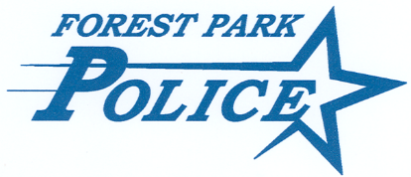

PRESS RELEASE

March 11, 2024 | Contact: Chief Ken Gross
For Immediate Release | Phone: 708-615-6299

Aggravated Discharge of a Firearm – 200 Block of Desplaines Ave.

Forest Park Police Officers were dispatched to the 200 block of Desplaines Avenue, Forest Park, IL on March 10, 2024 at approximately 7:21pm for a call of shots fired.

Upon arrival officers located one spent shell casing and learned a dispute among family members resulted in one family member firing a firearm. The offender fled the address in a vehicle prior to officers arriving. The involved family was uncooperative with responding officers.

Thankfully, nobody was injured in this reckless and dangerous act.

The Forest Park Police Department’s Criminal Investigations Division is actively investigating this incident.

If you have information related to this incident, please contact the Forest Park PD Criminal Investigations Division at 708-366-2425 or Detectives@ForestPark.Net.

###

