***Forest Park Home Fire Escape Planning and Practice***

Home fire escape planning and drills are an essential part of fire safety. The Forest Park Fire Department encourages everyone to develop and practice home fire escape plans before a fire strikes.

Home fire escape planning should include the following:

1. Draw a map of each level of your home, showing all doors and windows
2. Going to each room and pointing to the two ways out
3. Making sure someone will help children, older adults, and people with disabilities wake up and get out
4. Teaching children how to escape on their own in case you cannot help them
5. Establishing a meeting place outside and away from the home where everyone can meet after exiting
6. Calling 911
7. Having properly installed and maintained smoke detectors

Practice home fire escape plans at least twice a year. Once you are out of the house, stay out. Meet the fire department and let them know if anyone is still inside.

1. ***Draw a floor map… 2. In each Room point to 2 ways out…***

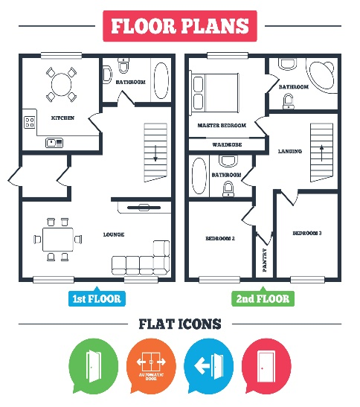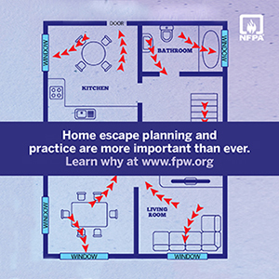

1. ***Help Others… 4. Escape on own…***

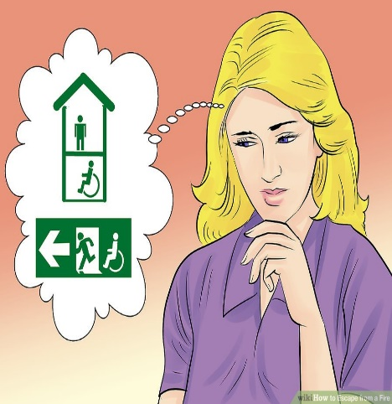 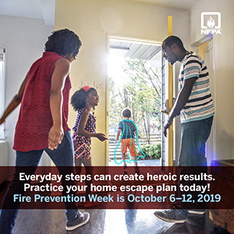

1. ***Pick a place ot meet after exiting 6. Call 911***

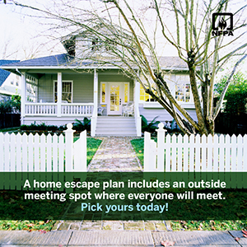

***7. Have properly installed and maintained smoke detectors***

